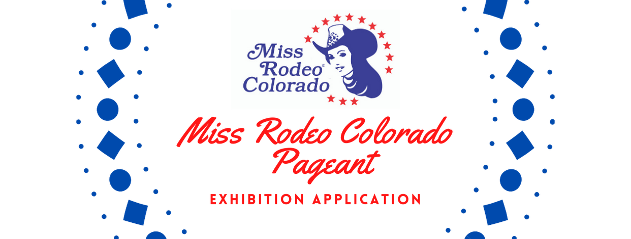

Name:
Address:
City: State: Zip code:
Phone Number:
Email Address:
Date of Birth:
Parent’s Names:
Parent Phone Number:
Emergency Contact (if not your parent):
Emergency Contact Phone Number:

I will need a stall for Exhibition: Yes No
I will need a horse for Exhibition: Yes No
(Horses may be provided on a limited basis for out-of-state competitors only)

For information regarding submission details, rules, and guidelines for the MRC pageant, please refer to the Miss Rodeo Colorado Official Rule Book at www.missrodeocoloradopageant.com. For the Exhibition Pageant, a printed copy of this application and your entry fee of $100.00 (certified check or money order) must be sent to Nyla Bristow at 7512 Plateau Rd., Greeley, CO 80634 and postmarked by the deadline of March 15, 2023. You must also email a copy of your application, a headshot, and a short bio (100 words or less) to missrodeocolorado@gmail.com by the same deadline. Your bio will only be used for introductions and the judges will not review it.

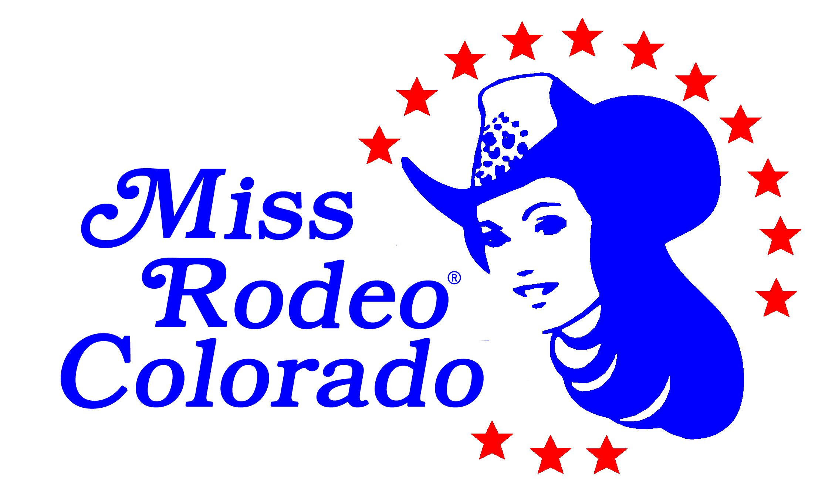
Miss Rodeo Colorado Pageant
Sponsored by the Greeley Independence Stampede
APPLICATION FOR EXHIBITION PAGEANT
Please type and complete both pages. Your application must fit on two pages.

Name
Hometown Date of Birth
Email Address
Circle the social media platforms that you currently use: Facebook Twitter Instagram
Education:

Scholastic Plans and Future Ambitions:

Experience with Rodeo, Horses, Horse Shows, etc.:

Honors and Awards:

Hobbies:

Why I Want to Become a Rodeo Queen: (200 Word Limit)

In consideration of my application being accepted, I hereby for myself, my executor, administrators and assignees, agree to abide, and that they shall abide, by all rules and regulations pertaining to the Miss Rodeo Colorado Pageant- and I and they assume all liabilities and responsibility for any loss, accident or injury, whether as to property or person, arising in any way out of the operations or activities of your committee or management, in any event or part of any performance of while in, on or about the premises of the Miss Rodeo Colorado Pageant in Greeley, Colorado. As for the consideration aforesaid, I further agree to indemnify your committee and management from and against any loss or damage sustained by you by reason of any claims made by any of my executors, administrators or assignees. Also, I hereby release the right, title and claim of any photographs that may be taken by the management for their use. I certify that I know the rules of the aforementioned pageant and agree to abide by them. The undersigned has read the foregoing release carefully and fully understands the meaning and effect to the same.

Applicant Signature Date

If Contestant in under 21 years of age,

Approved and attested by:
Signature of Parent or Guardian:

