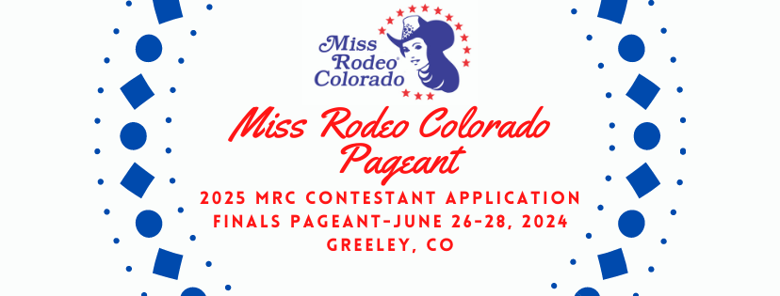

Name:
Address:
City: State: Zip code:
Phone Number:
Email Address:
Date of Birth:
Parent Names:
Parent Phone Number:
Emergency Contact (if not your parent):
Emergency Contact Phone Number:

List Hometown/Local Newspaper and Radio Station with Address:

For information regarding submission details, rules, and guidelines for the MRC pageant, please refer to the Miss Rodeo Colorado Official Rule Book at www.missrodeocoloradopageant.com. For the Finals Pageant, a printed copy of this application and your entry fee of $200.00 (certified check or money order made out to Miss Rodeo Colorado Pageant) must be sent to Nyla Bristow at 7512 Plateau Rd., Greeley, CO 80634 and postmarked by the deadline of June 1, 2024. Please do not request a signature for delivery of your application. You must also email a copy of your application, a headshot, and a short bio (100 words or less) to missrodeocolorado@gmail.com by the same deadline. Your bio will only be used for introductions and the judges will not review it.

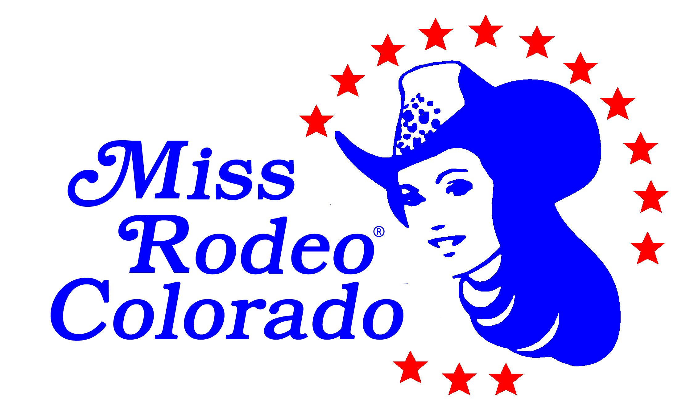
Miss Rodeo Colorado Pageant
Sponsored by the Greeley Independence Stampede
APPLICATION FOR MISS RODEO COLORADO
Please type and complete both pages. Your application must fit on two pages.

Name
Hometown Date of Birth
Email Address
Circle the social media platforms that you currently use: Facebook Twitter Instagram
Education:

Scholastic Plans and Future Ambitions:

Experience with Rodeo, Horses, Horse Shows, etc.:

Honors and Awards:

Hobbies:

Why I Want to Become Miss Rodeo Colorado: (200 Word Limit)

In consideration of my application being accepted, I hereby for myself, my executor, administrators and assignees, agree to abide, and that they shall abide, by all rules and regulations pertaining to the Miss Rodeo Colorado Pageant- and I and they assume all liabilities and responsibility for any loss, accident or injury, whether as to property or person, arising in any way out of the operations or activities of your committee or management, in any event or part of any performance of while in, on or about the premises of the Miss Rodeo Colorado Pageant in Greeley, Colorado. As for the consideration aforesaid, I further agree to indemnify your committee and management from and against any loss or damage sustained by you by reason of any claims made by any of my executors, administrators or assignees. Also, I hereby release the right, title and claim of any photographs that may be taken by the management for their use. I certify that I know the rules of the aforementioned pageant and agree to abide by them. The undersigned has read the foregoing release carefully and fully understands the meaning and effect to the same.

Applicant Signature Date

If Contestant in under 21 years of age,

Approved and attested by:
Signature of Parent or Guardian:

Miss Rodeo Colorado
Authorization for Release of Information

Name:
First Middle Last

Address
City: State: Zip Code:
Email Address: Date of Birth:

I hereby authorize and consent to the release of any and all information, including without limitation, all records, statements and opinions held by any person, employer, school, law enforcement agency, military personnel and any other entity or organization to the Miss Rodeo Colorado Executive Committee to verify information submitted by me as an applicant for Miss Rodeo Colorado.

I authorize the release of all records relating to my attendance at any school or educational institution, including without limitation, transcripts and other documentation of academic or athletic achievements, attendance records, incident reports and/or disciplinary actions. I also consent to a criminal background check and to the release of any and all information held by law enforcement agencies, including without limitation, arrest records, incident reports, motor vehicle driver’s history and criminal investigation reports.

I authorize the release of any and all employment records, including without limitation, my complete personnel file, applications for employment and any documentation of training, wages paid, performance or evaluation, advancement, demotion or change in pay, any grievances filed by or against me, and any corrective or disciplinary actions.

I hereby release any and all persons, entities, agencies and organizations, individually and collectively, from liability for damages of whatever kind relating to or arising out of any release of information including records, statements and opinions, as a result of this authorization.

A photocopy of this authorization shall be as valid as the original and for one year from the date it is signed.

I understand that my suitability for being a Miss Rodeo Colorado contestant or Miss Rodeo Colorado is based upon the results of this investigation and that my eligibility is conditioned on my receiving, in the Miss Rodeo Colorado Executive Board’s discretion, a satisfactory background investigation. I further understand that refusal to sign this form may result in disqualification.

I have read, understand, and by my signature, consent to the above statements.

Applicant Signature Date

Witness Signature Date

